 | SS-302:  Midterm Assessment Template

Name: | Wainel Santiago |  | Date: | 4/11/22
School: | Career in Sports Highschool |  | Grade/Subject: | 10th Global History
Collaborator(s), if Applicable:
All collaboration should be verbal in nature and each teacher should submit unique, individual written work for each assessment. Any additional resources consulted should be listed at the end of the assessment. The primary volume of your work should be yours and yours alone.
Note: while you are not required to use this template/format, your plans must be your individual, unique written work alone. Additionally, you may copy and paste the template if you are submitting multiple plans.

Planning and Alignment
Lesson Title/Topic
What encompassed the Cold War?

Aligned Standards

Reading: Craft and Structure:
CCSS.ELA-LITERACY.RH.9-10.4: Determine the meaning of words and phrases as they are used in a text, including vocabulary describing political, social, or economic aspects of history/social science.

Writing: Text Types & Purposes:
CCLS.ELA-LITERACY.WHST.9-10.2: Write informative/explanatory texts, including the narration of historical events, scientific procedures/ experiments, or technical processes.

Speaking and Listening: Comprehension and Collaboration:
CCSS.ELA-LITERACY.SL.9-10.1: Initiate and participate effectively in a range of collaborative discussions (one-on-one, in groups, and teacher-led) with diverse partners on grades 9-10 topics, texts, and issues, building on others' ideas and expressing their own clearly and persuasively.

CCSS.ELA-LITERACY.RH.9-10.3
Analyze in detail a series of events described in a text; determine whether earlier events caused later ones or simply preceded them.

CCSS.ELA-LITERACY.RH.9-10.9
Compare and contrast treatments of the same topic in several primary and secondary sources.

Learning Objective
SWBAT: To analyze the consequences of the Cold War and how political ideological realignments affected conflicts and governments around the world.

SWBAT: To analyze the advancement of technology throughout the Cold War because of political ideological realignment.

Source or Sources for the Inquiry Lesson
1.Teacherpayteacher website.
2. Doe Engageny.org
3. Co-Teacher/Doe-Mentor Meetings.

Teacher Exemplar:
- Please either upload or include in this box a teacher exemplar of the work you are asking students to do, i.e annotations to a reading, the written exit ticket or another written response.

Do Now:
Objective: | What was the Cold War?  - Describe what the Cold War was.

Introduction
➡ Directions: Examine the images below that were all created in the United States during the Cold War, then complete the See-Think-Wonder activity that follows.
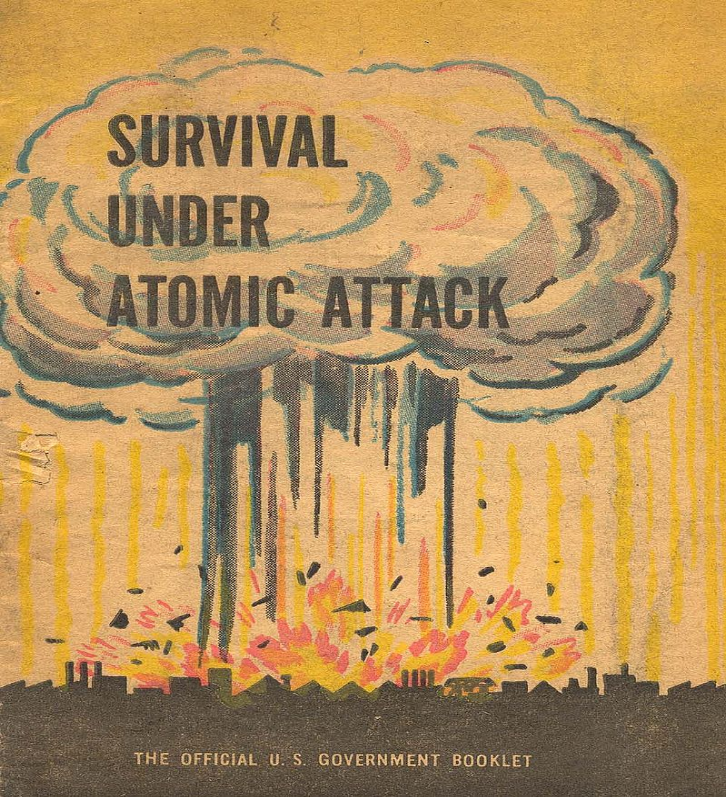  A booklet entitled “Survival Under Atomic Attack” issued in 1950 by the US Government.  Image is courtesy of wikimedia commons and is in the public domain | 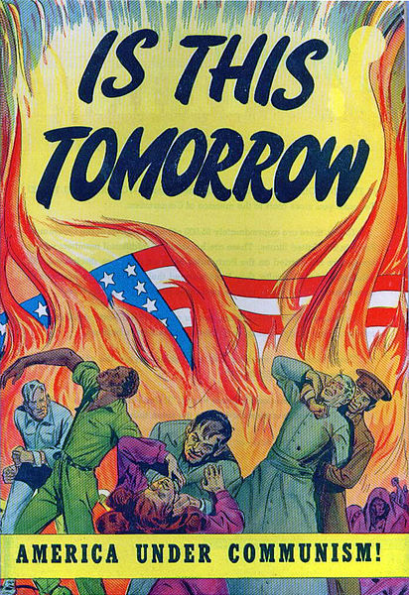  The cover of an American comic book published in 1947.  Image courtesy of Wikimedia Commons and is in the public domain.

See  Identify three things you observe in the images above. | Think  Based on these images, what concerned Americans during the Cold War? | Wonder  Write at least two questions you have about the images above.

  Contextualize | What was the Cold War?

Cold War | (1945-1991) a state of political and military tension after World War II between powers in the Western Bloc (the United States and its capitalist allies) and powers in the Eastern Bloc (the Soviet Union and its communist allies)

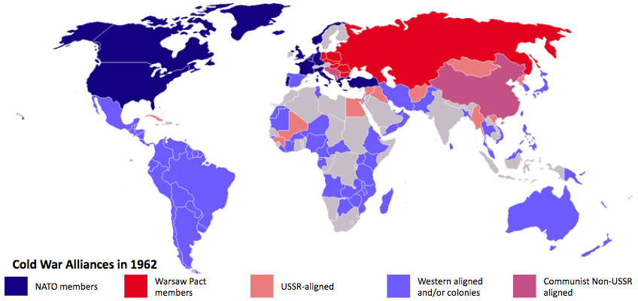
The Western Bloc  U.S.A. & NATO allies | vs. | The Eastern Bloc  Warsaw Pact allies & USSR
Economic System: Capitalism  Political System: Democracy | vs. | Economic System: Command Economy  Political System: Communism
The United States wanted to contain communism so they pursued the policy of containment. | vs. | The USSR wanted to promote communism and spread these ideas to other countries.
Containment was a strategy of keeping communism within its existing boundaries and preventing its further expansion. This policy meant the United States would support any nation facing an external or internal communist threat. | vs. | The promotion of communism was a strategy of expanding communism outside its existing boundaries. This policy meant the Soviet Union would support any nation facing external or internal aggression from the Western bloc.

 | ➡ Directions: Watch the video entitled “The Cold War in 7 minutes” from Academia Play EN (0:00-0:50) and read the transcript below, then answer the questions that follow.

Video Transcript:
The Cold War was a conflict that began at the end of the Second World War in 1945. The end of the war marked the end of the supremacy of Europe. Two powers took over: the United States and the Soviet Union leading two blocs with their own alliances and satellite states. The so-called Western bloc [were] capitalists and the Eastern Bloc were communists.

Why was it called the Cold War? Because neither of the two blocs ever took direct actions against the other. It wasn't a normal war although there were derivative conflicts and subsidiary wars [conflicts related to the competition between the USA and USSR]. The reasons for this conflict were essentially ideological, political, economic, and for propaganda purposes. The Soviet Union financed and supported revolutions and socialist governments, while the United States gave open support [to capitalist countries].

1. The Cold War took place after which war?

2. Which countries were the most powerful during the Cold War? How were those two countries different?

3. Why was the Cold War called “cold?”

FA | SQ 1. What was the Cold War?
  Contextualize | Content and Vocabulary Checklist  Use the checklist below to assess the use of important content and vocabulary in the unit.  Task: Describe what the Cold War was.
  Self  Yes/No | Teacher  Yes/No | Did you use the content and vocabulary below in your response?
   |  | World War II
   |  | tension
   |  | USSR/Soviet Union
   |  | USA/United States
   |  | capitalism/capitalist
   |  | communism/communist

Independent study. FOR TEACHER MODELING.
FIDEL CASTORS I AM A MARKIST LENNIST SPEECH 1/3
Scanned by Walter Lippmann from Fair Play for Cuba Committee pamphlet published in 1962. Slight editing to correct typos, and some formatting. Subheads in the original If you catch any errors, report them to walterlx@earthlink.net The Spanish original is not online. Yet. Enjoy! Pamphlet had 83 pages. Speech has approximately 37 thousand words. February 14, 2007.}
Why is the United Party of the Socialist Revolution a necessity?
I would certainly have liked a little more time to make a serious study of this topic, since the subject of the United Party of the Socialist Revolution is a matter of extraordinary importance to the Revolution. I, therefore, told some of my comrades that I was going to give a sort of provisional talk now, since I expect to return to this question in the future when I have more time to develop it thoroughly.
I am, therefore, simply going to express at this time a series of fundamental ideas with which the United Party of the Revolution is concerned.
In the first place, what is the United Party of the Revolution and why is it being organized? Of course, on previous occasions, in different public ceremonies, we have already referred to thlo4ues.- tion and have expressed certain ideas about it.
The United Party of tile Revolution was, in the first place, a necessity. Why was it a necessity? To begin with, you cannot make a revolution, and above all, you cannot carry a revolution forward without a strong and disciplined organization.
This necessity is becoming more and more evident as the revolutionary process advances and deepens and faces even more difficult tasks.
It has always been said, and rightly so, that it is easier to win power than to hold it; it is easier to win power than to govern.
And that is a great truth. The tasks a revolutionary movement faces in the struggle for power become enormous and multiply the minute that revolutionary movement seizes power. It has also been said in various books, (and we are really reviewing all of the boors we have read and studied, seeing that we all studied in places where we often had to learn a lot of foolishness, things of no great importance); it has been said that the harder it is to win power, that is, consolidate it, the easier it is to keep it; that the easier it is to win power, the harder it is to hold on to it.
The only truth there can be in that assertion is basically the following: that it is in the struggle for power that the cadres who will later govern the country are trained. The longer and more protracted the struggle, the greater the number of men it trains capable of later discharging other duties.
To recall briefly the experience, our experience, an experience that was relatively short when compared with much longer struggles which other countries had to wage, armed struggles, as for example in China where the guerillas fought for more than 20 years before they seized power. Of course, the struggle for power does not begin only at the moment of armed conflict.
I remember when we gave the word to strike, prematurely, when the revolutionary movement made what you could call an error in evaluating the objective conditions, already trying to seize power in April, 1958.
At that time, we still had very few men. If I am not mistaken, the total of our guerilla forces numbered about 180 combatants. When we decided to open the Second Front, we did it with 50 men; we opened the front around Santiago de Cuba with 35 men; and this left other forces that numbered no more than 130 men, all told, perhaps less; there were fewer than 100 men left in the Sierra Maestra at the time.
Resisting with Limited Resources
Well, if, at that time, we had succeeded in overthrowing the tyranny from the military point of view, our military leaders would not have been able to get the experience they got later. Up to that time, our guerilla forces had never launched a serious frontal attack from prepared positions against the enemy forces. It had been, indeed, a guerilla war.
However, it was during the last stage of the struggle, right after the failure of that attempt to seize power, when the guerilla forces faced the most complex and crucial military problems. Once, we had to defend some national territory that we could not abandon because we had set up workshops, the Rebel Radio Station, and a whole lot of fighting equipment there which we would lose if the enemy took over.
We had to make a stand there with the limited resources at our disposal.
Among other things, we had to regroup all our forces, excepting those at the Second Front in Oriente, to resist the enemy offensive and we8
However, that new situation brought about a serious battle in defense of that territory, which was getting smaller and smaller, to the point where we could not, allow it to get any smaller. We fought some important battles. Once, the enemy surrounded us and we surrounded them, in turn. An enemy battalion surrounded us and other enemy forces surrounded our other forces. But we had our first successes here in that sector, we became stronger and were able to counterattack. But one thing is certain: A complex battle developed and we acquired a lot of experience from it. And the experience,'and arms, and men strengthened by that struggle made it possible for us to start more important operations, for example, the invasion of Las Villas.
The Fight Against the Army
It goes without saying that without the men forged by those 71 days of fighting, it would have been difficult to undertake the invasion of Las Villas from Oriente.
The more we analyse the conditions under which we began that operation, the number of men who carried it out, facing an enemy militarily much stronger, the more extraordinary a feat it seems. crossing all Camaguey from Oriente without cover, without anything in our favor, and arriving in Las Villas was a truly :great feat.
One often wonders how this was possible. The answer is simply that the men who made the crossing were comrades who already had an extraordinary confidence in themselves, had developed a great composure, a great skill and were men who were fully tested. These are the things that made it possible to undertake that operation, and those operations in the lowlands that at first seemed incredible.
In other words, the continuation of the struggle kept developing a set of human values, and the ability to carry out more and more difficult tasks, and we kept on acquiring more experience.
So that by the war not ending in April but at the end of the year, the Revolution, at the moment of triumph, could count on a large group of comrades tested in battle and quite experienced.
Can anyone deny that all the experience acquired in those months has become of the greatest importance to the Revolution now? If we have a large number of comrades competent in defending the Revolution against imperialist attacks; if the Armed Forces of the Revolution can face up to the enemy planes, to oppose his aggression, then that is due, in great part, to the fact that the prolongation of the struggle developed a group of leaders. Of course, not in what they
understood when the war ended; but still they at least were tested men, known men, who in time, after the triumph of the conquest of power were able to develop even more.
And so, we have many comrades who took part in all those military actions who today have been trained in our military academies and who have devoted themselves fervently to study. Of course, all this involved a little work. The guerilla war from which most of our leaders sprang up -- although at a given moment it was no longer a guerilla war, but a war of major proportions, of maneuvers, and of positions -- made those who came out of it feel a certain scorn for military academies, a certain disdain for military theories and military manuals. That is an attitude we must overcome, though it will be hard at first. But this training has already brought about a change in the thinking of our war companions, a change in their attitude. And in fact today there is not a single revolutionary leader who is not interested in attending the academies.
Well, then, our military schools are training comrades of high rank, and it is not rare to find a major going to a school for sergeants and taking a course for privates, for one of the things we are doing is to see that, they learn about the problems of the people whom they are going to lead. And they are doing so with extraordinary enthusiasm.
But the continuation of the struggle resulted in all those men ending up the war with much, and enough experience of a military nature, experience that was to develop still further in the months ahead.
This is an example from the military field which is exactly the same as other fields, when it comes to organization, when it comes to the solution of administrative and political problems. During the struggle, of course, we didn't have vast areas to administer. In China, for example, they had a lot of problems, indeed, to resolve, even before they seized power. There were certain problems that we discussed after seizing power, such as the problems relating to art, which the revolutionary movement in China discussed before they seized power.
The Political Struggle Developed Revolutionary Values
It can't be said that there weren't experienced men among us. No one can deny that the political struggle in our country has developed a series of values in the public life of our country, revolutionary values and well-trained men. In the end, however, the Revolution came to power. Under what conditions does a revolution come to power? Does it come with an organized and disciplined movement perfectly prepared for the c' 'pies of government? No. Do all of the revolutionary forces organic, embodied in that revolutionary movement come to power? No.
There is only one revolutionary movement, not two or three or four revolutionary movements. There is really one revolutionary movement and, in the long run, revolution or counter-revolution. A revolutionary movement can be more or less limited; with a revolution, it is possible to reach the objectives the revolution has set (and it cannot be denied that they may be revolutionary as far as they go) and from that moment, either the revolution ceases to be truly revolutionary or it goes forward. In other words, one movement can be more or less radical, which cannot be the case with two, three or four revolutionary movements. That's absurd. Furthermore, those other movements are really counter-revolutionary.
The Various Revolutionary Forces
The truth is that a revolution does not come to power with an organization that embodies all of the revolutionary forces. There were different revolutionary organizations, and these different revolutionary organizations represented different revolutionary forces. In the common goal that united all revolutionary and nonrevolutionary organizations -- because there were forces against Batista's tyranny which you could not call revolutionary -- there were politicians who were simply against Batista because he had kept them out of his government; there were politicians of the ruling classes, those very ruling classes that Batista's government represented, who were really angling for a change of power. The politicians ousted from power, for example, on March 10th, that whole political group headed by the celebrated Sr. Carlos Prio Socar•as, was a group that in the long run represented the same interests as Batista. They, as agents of imperialism dressed in mufti, and Batista, as an agent of imperialism with a milit ary apparatus, an apparatus of force and oppression.
All those people...What did those people intend to do when they got into the government? Did they intend to do anything different from what they did? Let us imagine for just a second that the group of Prio, Tony Varona and their ilk had come to power. Of course, that was-vi•tually impossible. Here you had Prio, Tony Varona and that whole crowd after maybe ten or twelve years in exile alone and they've entered into an election, in a deal with Batista, content just to serve as senators or mayors or provincial governors. That's the way everything ended up. But let us imagine hypothetically that those people had regained power, were once again ruling our country.
What would they have done? What would they have done that was different from what they did in the years when they were in power? They were definitely going to do exactly the same thing, that is, serve the interests of imperialism and serve the interests of the upper middle classes here, insofar as those interests did not conflict with the interests of imperialism, because the interests of imperialism -- that is, the foreign monopolies -- had a privileged position here in our country, even at the expense of the native middle classes.
They Were Going to Squeeze You Dry
Those people in power would have simply limited themselves to doing the same as they had done. They would not have passed a single revolutionary law; they would not even have reduced rents, as the Revolution did, let alone instituted an Agrarian Reform or Educational Reform, or reform of any kind. Everybody knows what those people would have done. What would they have done? Don't you know? I am talking to the people. What would they have done, had they attained power? Listen to me, Lionel, it seems that this subject was not explained to your students at the School of Revolutionary Instruction. Man, everybody knows that!
What they did was to rob; what the government and that whole crowd would simply have done was to rob. That is, they were going to squeeze you dry for their services to the ruling economic interests. They would have maintained a professional army, instruments of repression; they would have maintained all the organs of persecution; they would have maintained the existing social system -- that's all. In other words, there was a group representing the dominant economic interests and imperialists which was against Batista simply because they wanted to be the ones in the government; they did not at all like having Batista and Batista's clique instead of them doing the robbing. Of course, they would be against Batista.
What did they do against Batista? Not a thing, absolutely nothing! They devoted themselves to the purchase of arms, to bringing arms here. Often they were successful in bringing them into the country, although they never had the least success in using them; they never even used them.
Everyone remembers the great supply of arms which they smuggled. into the country and which the police seized. At the time when we were beginning to set up a revolutionary movement, to train some young people; at a time when we were expecting to see those bigwigs of public life, men with money and property, do something effective against the Batista dictatorship. They had arms, they had money, they had everything; in fact, all they lacked was the will to fight. They were merely playing at revolution. It is true that they brought arms into the country, were looking for people, instructed them in the use of the arms. There were a number of cliques. They acted exactly as they did in the ward politics. Some of them had one or two machine guns hidden and they were looking for people in the wards to fight Batista. How did they win them over? They taught them how to use a machine gun. But, it was the same old, classical politics carried over into the insurrection. Well, these characters were politicking with machine guns; for, indeed, they were all of them thinking of when Batista would fall, one way or the other, and they would bring back the same old thing.

Exit ticket
Homework if not finished

Global Regents Prep:
The Cold War
As soon as World War II ended, the two superpowers of the world, the United States and the Soviet Union, began to try to control whether the world would be democratic and capitalist, like the United States, or communist, like the Soviet Union. This struggle took place for the next 40 years and was known as the COLD WAR.
Some major events in the beginning of the Cold War:
Truman Doctrine 1947: President Truman offered the financial and military support of the United States to any country in Europe trying to prevent the spread of communism in their country. This was used to try to stop Greece and Turkey from becoming communist after the end of World War II.
Berlin Airlift (1948-49): After World War II, Germany was divided into four sections. Each section was controlled by the four Allied powers that had won World War II (United States, Great Britain, France and the Soviet Union). The city of Berlin, the capital of Germany, was in the Soviet section of Germany. The city of Berlin was also divided into four sections.
The Soviet Union wanted to make their section of Germany communist, and also wanted the city of Berlin to be part of the communist part of Germany. The Soviet Union closed all roads and railroads into Berlin, so the United States, Great Britain and France could not enter the city and give food or supplies to the people in their sections of Berlin.
The United States, Great Britain and France decided to carry out the Berlin Airlift, which carried all of the food and supplies the people of Berlin would need to survive for the next year. The Soviet Union eventually opened the roads, and the people in West Berlin remained part of West Germany, which was democratic.
Germany would remain divided into East and West Berlin from 1945 until 1990.
Korean War (1950-53): The Korean War was fought between the North and South of Korea. The South was supported by the US after South Korea was invaded by North Korea. North Korea and was supported by communist China and the Soviet Union. The war stopped in 1953, and to this day North Korea remains communist and South Korea remains democratic.
Cuban Missile Crisis (1962): The Cuban Missile Crisis was when the Soviet Union installed nuclear missiles in Cuba that were capable of hitting the United States. Cuba is only 90 miles off the coast of Florida. The US President, John Kennedy, demanded that the Soviet Union remove the missiles and put US warships around Cuba, blocking any ships from coming in. The world waited as most people expected the United States and the Soviet Union to launch a nuclear war, but both sides backed down. The Soviet Union removed the nuclear weapons from Cuba and the United States promised to not invade Cuba and remove nuclear weapons close to the Soviet Union in Turkey.

The US policy of trying to stop the spread of communism was called containment.
1. The Truman Doctrine, Korean War, crisis in Guatemala, and the Soviet Invasion of Afghanistan were all 1. reasons for the Industrial Revolution
2. examples of Japanese imperialism
3. events of the Cold War
4. causes of World War II
* Berlin Airlift
* Cuban Missile Crisis
* Nuclear arms race
2. These events were part of an era known as the
1. Age of Imperialism
2. Scientific Revolution
3. Enlightenment
4. Cold War
"United States Airlifts Supplies to Berlin"
"U-2 Spy Plane Shot Down Over the Soviet Union"
"Soviet Missiles Placed in Cuba"
3. These headlines discuss events during
1. Stalin's Reign of Terror
2. World War II
3. the Cold War
4. the post-Cold War era
"Korea Divided at the 38th Parallel"
"Hungarian Revolution Crushed"
"Missile Sites Spotted in Cuba"
4. These events in these headlines contributed to the
1. development of peacetime alliances
2. collapse of the Soviet Union
3. rejection of imperialism by Western nations
4. tensions between the superpowers
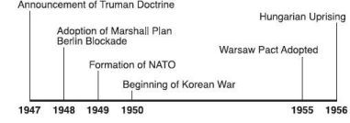
5. All the events on the time line show actions taken during the
1. policy of appeasement
2. Cold War
3. decline of nationalism
4. Green Revolution
US POLICIES DURING COLD WAR
Containment
Containment was the US policy after World War II that tried to stop the spread of communism. The United States would give financial aid to countries around the world to prevent countries from becoming communist.
1. After World War II, the United States provided financial aid to West Germany, Turkey, and Greece because these nations were
1. beginning their industrial development
2. facing possible communist threats
3. newly independent
4. major military partners of the United States
2. Which United States foreign policy was used to maintain the independence of Greece and Turkey after World War II? 1. containment 3. nonalignment
2. neutrality 4. militarism
Marshall Plan / Truman Doctrine
Marshall Plan: After World War II, the United States announced the Marshall Plan, which would give aid to European countries to help recover from the damage of World War II. The United States wanted European countries to take American aid so that they would be able to recover quickly and become democratic countries like the United States.
1. The purpose of the Marshall Plan was to
1. restore Japanese economic development
2. provide military aid to Middle Eastern allies
3. assure nationalist success in the Chinese civil war
4. provide for economic recovery in Western Europe
2. The Truman Doctrine and the Marshall Plan were designed to
1. promote economic and political stability in Europe
2. end German demands for the Sudetenland
3. restore democratic rule in Haiti
4. prevent Iraq's takeover of Kuwait

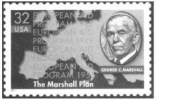
3. This commemorative stamp was issued 50 years after the Marshall Plan. George Marshall was honored because he had 1. insisted that Germany and the other Axis Powers pay for starting World War II
2. proposed economic aid from the United States to rebuild the economies of European nations 3. formed the European Union so that Western Europe could rebuild its own economy
4. encouraged Western European nations to accept aid from the Soviet Union
Iron Curtain
The Iron Curtain refers to the divide between Western and Eastern Europe after the end of World War II. Winston Churchill, the leader of Great Britain during World War II, was the first person to use the expression.
Western Europe and the United States became democratic countries that formed NATO (North Atlantic Treaty Organization) after World War II. They promised to defend each other if any of them were attacked by Communist countries.
Eastern Europe and the Soviet Union were communist countries that formed the Warsaw Pact after World War II. They promised to defend each other if any of them were attacked by Western Europe or the United States. The Soviet Union controlled the communist countries of Eastern Europe through economic and military power.
The Soviet Union used violence against the people of communist countries who wanted to be free. Violence was used against the people of East Germany, Czechoslovakia, Poland and Hungary when the people tried to start democratic governments.
Examples of Eastern European countries trying to fight back against communism include the Hungarian Revolution, Prague Spring, and the formation of Solidarity in Poland.
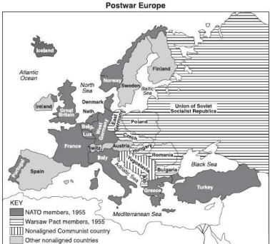
1. Which speech described the political alignment shown on the map?
1. Pericles' "Funeral Oration"
2. Bismarck's "Blood and Iron"
3. Hirohito's "Surrender"
4. Churchill's "Iron Curtain"
"From Stettin in the Baltic to Trieste in the Adriatic, an iron curtain has descended across the continent." - Winston Churchill (1946)
2. This statement refers to
1. beginning of the Cold War
2. unification of Germany
3. end of World War I
4. Russian Revolution
3. After World War II, the Soviet Union maintained control of many Eastern European nations mainly because these nations were
1. a source of new technology and skilled labor
2. near warm-water ports on the Mediterranean Sea
3. extensions of communist power
4. members of the North Atlantic Treaty Organization (NATO)

4. In Eastern Europe during the 1950's and 1960's, the Soviet Union responded to challenges to its control by 1. allowing free elections, when necessary
2. imposing prompt severe repression
3. obtaining United Nations assistance
4. granting independence to its satellite nations
* Hungarian Revolution (1956)
* Prague Spring (1968)
* Formation of Solidarity in Poland (1979)
5. One way in which these events are similar is that each is an example of
1. a reaction of a Warsaw Pact nation to the actions of the North Atlantic Treaty Organization (NATO) 2. violence resulting from massive food shortages
3. opposition to communism in Eastern Europe
4. the failure of the European Economic Community (Common Market) to unify its tariffs Berlin Wall
The Berlin Wall was built around the Soviet controlled part of East Berlin in 1961 to stop Germans from moving to West Berlin, which was democratic and part of West Germany. Many East Berliners were escaping to West Berlin to not be part of Communist East Germany.
The Berlin Wall surrounded East Berlin until 1989, when the Soviet Union was losing control of Eastern Europe and communism began to collapse across Eastern Europe. Communism would end across Eastern Europe and the Soviet Union in the late 1980’s and early 1990’s.
1. One reason for the construction of the Berlin Wall in 1961 was to
1. promote reunification of East Germany and West Germany
2. keep East Germans from fleeing to the Western sector of Berlin
3. compete the post-World War II rebuilding of Berlin
4. meet the requirements of the North Atlantic Treaty Organization (NATO)
2. The destruction of the Berlin Wall in 1989 is symbolic of the
1. end of the Soviet domination of Eastern Europe
2. declining power of North Atlantic Treaty Organization (NATO)
3. fall of the Weimar Republic
4. collapse of the European Union
3. The fall of the Berlin Wall was followed by
1. and end of democratic rule in Germany
2. the rise of a Neo-Nazi movement in Spain
3. an expansion of the Warsaw Pact
4. the collapse of communism in the Soviet Union
* Blockade of Berlin
* Operation of the Berlin Airlift
* Organization of the Warsaw Pact
* Construction of the Berlin Wall
4. The events of the Cold War are examples of
1. efforts to prevent military conflict between the superpowers
2. situations that increased tensions between communist and democratic nations in Europe
3. attempts to weaken the Soviet Union's control of its Eastern European allies
4. policies of peaceful coexistence and detente
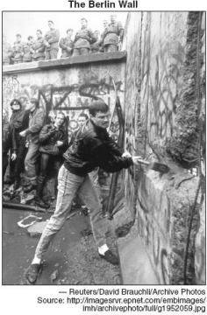
5. This 1989 photograph symbolizes the
1. end of the Cold War
2. importance of the Berlin Airlift
3. creation of a divided Germany
4. fear of Nazism among Germans
NATO / Warsaw Pact
Western Europe and the United States became democratic countries that formed NATO (North Atlantic Treaty Organization) after World War II. They promised to defend each other if any of them were attacked by Communist countries.
Eastern Europe and the Soviet Union were communist countries that formed the Warsaw Pact after World War II. They promised to defend each other if any of them were attacked by Western Europe or the United States. The Soviet Union controlled the communist countries of Eastern Europe through economic and military power.
Some European countries decided to not join NATO or the Warsaw Pact, such as Austria, Spain, Sweden, Switzerland and Yugoslavia.
1. One reason the Soviet Union formed the Warsaw Pact was to
1. ease the transition to democracy
2. help institute capitalism in Eastern Europe
3. limit the threat of invasion from Western Europe
4. challenge the economic successes of the Common Market
2. The purpose of the Truman Doctrine and the North Atlantic Treaty Organization (NATO) was to provide 1. economic aid and military support to European nations to stop the spread of communism 2. military troops to end ethnic warfare in the former Yugoslavia
3. humanitarian aid to starving people in Ethiopia and Sudan
4. the rights of freedom of speech and the press to Greek and Turkish citizens
3. Which of these countries was not a member of either the North Atlantic Treaty Organization (NATO) or the Warsaw Pact?
1. East Germany
2. Great Britain
3. Rumania
4. Austria
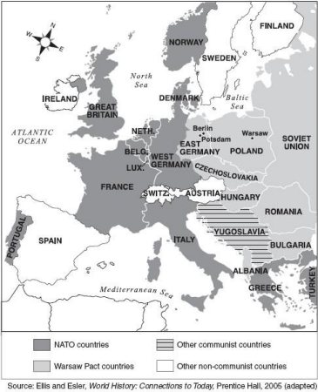
4. Which time period is represented in this map of Europe?
1. before the Congress of Vienna
2. during the Age of Imperialism
3. between World War I and World War II
4. during the Cold War
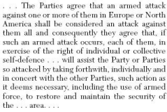
5. Which organization includes this statement in its charter?
1. Warsaw Pact
2. United Nations
3. Organization of American States
4. North Atlantic Treaty Organization
Cuba and Fidel Castro
Fidel Castro was the leader of a revolution in Cuba that got rid of a dictator in Cuba and led to a communist government being in Cuba from the late 1950s to today. Fidel Castro has been the leader of Cuba since the late 1950s.
During the Cold War, Cuba was given military and financial support from the Soviet Union.
Since the end of the Cold War, Cuba has had a hard time staying a communist country because of many economic problems. Since the 1960s, the United States has had an embargo with Cuba, which means the United States does not trade with Cuba or allow people to travel between the United States and Cuba.
1. Under the leadership of Fidel Castro, Cuba has become an example of
1. the success of democracy in improving conditions in a developing nation
2. a nation in which the efforts of the United Nations has improved human rights
3. a communist government struggling to maintain power despite economic problems
4. the successful reform of agriculture from single-crop to multicrop production
2. Since the end of the Cold War, Cuba has experienced
1. the loss of a major source of its foreign financial support
2. increased economic growth from expanded trade
3. expanded political influence in Latin American affairs
4. greater independence from Communist China
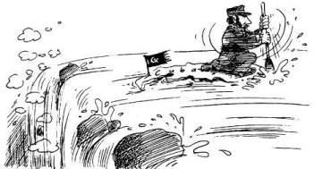
3. What is the main idea of this cartoon about Cuba?
1. the people have rebelled against their unpopular Communist leader
2. Fidel Castro's strong Communist leadership has assured the prosperity of the Cubans
3. Castro is struggling to maintain a Communist state
4. Castro's regime is being destroyed by the policies of the United States
"Cuba today is a land of impossible contradictions, a utopia with beggars, a so-called puppet still dancing after the puppet master's death."
4. In this 1993 newspaper quotation, which nation is referred to as the "puppet master"?
1. Haiti 3. Spain
2. Soviet Union 4. United States
5. Since 1989, why has Cuban influence in Latin American declined?
1. the transition from Marxism to capitalism has preoccupied Cuba's political leadership
2. a series of severe droughts has crippled Cuba's sugar industry
3. improved relations with the United States have allowed Cuba to focus on internal problems 4. the collapse of the Soviet Union has intensified Cuba's economic problems
Cold War Conflicts in Southeast Asia
Korean War
The Korean War was fought from 1950-1953 and was the next major war after the end of World War II in 1945.
The United States supported South Korea during the Korean War because North Korea was a communist country that was supported by Communist China and the Soviet Union.
The Korean War ended in 1953 with a truce that led to North and South Korea remaining divided to this day.
The Korean War is an example of containment, when the United States offered financial and military support around the world to stop the spread of communism after the end of World War II.
1. Which set of events is in the correct chronological order?
1. Renaissance --> Middle Ages --> Roman Empire
2. Treaty of Versailles --> World War II --> Korean War
3. Reformation --> Crusades --> European exploration of the Americas
4. Bolshevik Revolution --> French Revolution --> American Revolution
2. The formation of the North Atlantic Treaty Organization (NATO), the division of Germany into East Germany and West Germany, and the Korean War was immediate reaction to
1. Japanese military aggression in the 1930s
2. the rise of German nationalism after World War I
3. ethnic conflict and civil war in Africa in the 1950s
4. communist expansion after World War II
3. The main reason the United Nations sent troops to Korea in 1950 was to
1. ensure that food reached areas of the Korean Peninsula affected by famine
2. prevent North Korea from conquering the people of South Korea
3. force the inspection of nuclear weapons plants in North Korea
4. restore peace between warring factions of Buddhism and Shinto
4. During most of the Cold War period, which two nations were divided into communist and noncommunist parts? 1. China and Mongolia
2. Vietnam and Korea
3. Pakistan and Ireland
4. Poland and Cuba
Vietnam War
The Vietnam War was fought between the Communist North Vietnam and the democratic South Vietnam during the 1960’s and 1970’s. The United States became heavily involved in the Vietnam War, as they were supporting South Vietnam from becoming communist.
Vietnam is a country in Asia that surrounds
The United States becoming involved in Vietnam is an example of containment.
After the Vietnam War ended and US troops left, North Vietnam conquered South Vietnam and the entire country became known as Vietnam, a communist country to this day.
1. One difference between the war in Korea in the early 1950's and the war in Vietnam in the late 1960's is that 1. the United Nations played a major role in ending the war in Vietnam, but a minor role in ending the war in Korea 2. tactical nuclear weapons were used in Korea, but not in Vietnam
3. after the wars ended, Korea remained a divided nation, but Vietnam was reunited under a communist government
4. Untied States forces played a minor role in the war in Vietnam
2. Which of these nations is located closest to the Philippines, Malaysia, and Indonesia?
1. Korea 3. Somalia
2. Vietnam 4. Pakistan
3. One similarity between the Korean War and the Vietnam War is that both wars were
1. resolved through the diplomatic efforts of the United Nations
2. fought as a result of differing political ideologies during the Cold War
3. fought without foreign influence or assistance
4. caused by religious conflicts
4. From the perspective of the North Vietnamese, the war in Vietnam in the 1960's was a battle between 1. fascism and liberalism
2. nationalism and imperialism
3. republicanism and totalitarianism
4. theocracy and monarchy
Ho Chi Minh
Ho Chi Minh was the leader of Communist North Vietnam who wanted to unite the country of Vietnam as a Communist country.
Ho Chi Minh was able to unite his country through nationalism. He told the people of North and South Vietnam that the country should be united, and that the country should be run by Vietnam, not European countries or the United States. The people of Vietnam had been controlled by France, Japan and the United States, and wanted to control their own country.
Ho Chi Minh combined spreading the ideas of nationalism and communism to get the support of the people of Vietnam and win the war in Vietnam.
1. Within their respective nations, Ho Chi Minh and Fidel Castro achieved their goals by
1. seeking aid and support from the European Union
2. using armed conflict to bring a communist government to power
3. following a policy a nonalignment
4. working to build a capitalist system
2. One similarity in the actions of Ho Chi Minh and Jomo Kenyatta was that both leaders
1. introduced Western ideas to their societies
2. established democratic forms of government
3. led nationalist movements
4. supported separation of church and state
3. One way in which Simon Bolivar, Camillo di Cavour, and Ho Chi Minh were similar is that they 1. encouraged a spirit of nationalism among their people
2. enlisted the support of European nations to achieve their goals
3. opposed territorial expansion of their nations
4. followed the ideas of Thomas Hobbes in establishing systems of government
4. A factor that contributed to the success of both Ho Chi Minh in Vietnam and Mao Zedong in China was their ability to combine
1. imperialism and traditionalism
2. nationalism and communism
3. ethnocentrism and democracy
4. isolationism and capitalism
The Cold War Ends / The Collapse of the Soviet Union
Mikhail Gorbachev
The Soviet Union in the 1980’s was beginning to collapse. The major reasons were that the Soviet Union’s economy was collapsing and their military spending was too high.
The Soviet Premier, Mikhail Gorbachev, was trying to make changes to the Soviet Union so that it could survive. He made reforms that thought would save the Soviet Union, but the reforms led to the Soviet Union’s collapse, the end of Communism in Eastern Europe, and the end of the Cold War.
Mikhail Gorbachev decided to stop the policy of the Soviet Union interfering in Eastern Europe’s governments. This led to Eastern European countries moving away from communism and becoming democratic, including the Soviet Union. “By gently pushing open the gates of reform, he unleashed a democratic flood that wiped out the Soviet universe and washed away the Cold War."
1. This statement most likely describes the actions of
1. Ruholla Khomeini 3. Pol Pot
2. Ho Chi Minh 4. Mikhail Gorbachev
".... the Communist party of the Soviet Union has been and remains a natural and inalienable part of social forces. Their cooperation will make it possible to attain the ultimate goal of Perestroika: to renew our society within the framework of the socialist choice, along the lines of advance to a human democratic socialism... "
2. Which leader would most likely have made this statement?
1. Kwame Nkrumah
2. Mohandas Gandhi
3. Benito Mussolini
4. Mikhail Gorbachev
3. In the late 1980's, Mikhail Gorbachev's decision to stop interfering in the internal affairs of Eastern European nations led directly to
1. the collapse of the free-market economies in the region
2. an increase in Cold War tensions
3. a renewal of religious violence between Orthodox Christians and Russian Jews
4. the collapse of the communist governments in the region
4. One way in which Lech Walesa, Mikhail Gorbachev, and Nelson Mandela are similar is that each 1. led the people of his nation toward a more democratic government
2. fought for power for the black majority over the white minority
3. worked to end communism in his country
4. refused to participate in the United Nations
Perestroika / Glasnost
Perestroika was a policy Mikhail Gorbachev brought to the Soviet Union during the 1980’s to change the economy and society of the Soviet Union. Gorbachev allowed for capitalism, private property and other economic reforms away from a command economy.
Glasnost was a policy of openness to the Soviet Union’s communist government that Gorbachev thought would allow for communism to remain in the Soviet Union.
The economic and political reforms of Perestroika and Glasnost led to the end of Communism in the Soviet Union and Eastern Europe and the end of the Cold War.
1. One similarity between Mikhail Gorbachev's perestroika and Deng Xiaoping's Four Modernizations is that each 1. allowed elements of capitalism
2. maintained the democratic process
3. strengthened communism
4. increased global tensions
2. In the 1980's, Mikhail Gorbachev's attempts to change the Soviet Union resulted in
1. an increase in tensions between India and the Soviet Union
2. a strengthening of the Communist Party
3. a shift from producing consumer goods to producing heavy machinery
4. a series of economic and political reforms
3. Mikhail Gorbachev instituted the policies of glasnost and perestroika to
1. reinforce the basic economic principles of communism
2. bring the Soviet Union into the European Economic Community
3. reform the Soviet Union politically and economically
4. gain acceptance for free political elections
4. In the Soviet Union under Mikhail Gorbachev, the trend toward private ownership of businesses represented a move away from
1. a traditional economy
2. a command economy
3. a free-market economy
4. laissez-faire economics
5. One similarity between V.I. Lenin's New Economic Policy and Mikhail Gorbachev's policy of perestroika is that both policies
1. supported collectivization of farms in the Soviet Union
2. allowed some aspects of capitalism in the Soviet economy
3. increased citizen participation in the Soviet Government
4. strengthened governmental control over the Soviet Republics

Compelling Central Historical Question: remember this should allow students to do some interpretation or thinking.
- Describe what the Cold War was, what contributed to political ideological realignment and its impact around the world?
Opening |  | Time |  | 5-10 minutes.
- How will you activate background knowledge and stage the compelling question?
- How will you activate background knowledge?
- How will you facilitate retrieval practice ( You can script out how you will execute it and what questions you will ask. Be sure they are aligned to this inquiry lesson.

Do Now: (5-10 minutes)

- Students are asked to analyze a pair of images and to answers some of the questions.

- Teacher explains that students will practice interpretational and argumentation skills to evaluate what the Cold War was and its components around the world. The teacher distributes the Progress and Decline Tool to the students.
- Teacher reminds students that it is important to explain their reasoning for describing the cold war and its impact around the world.
- Teacher projects the cold war Alliances map and directs students to draft a definition for the word “realignment” based on the information provided on the map. Teacher asks students “why do you think the world realigned it self according to political ideologies?
- Students will discuss and record the definition of the term realignment with a partner.

Introduction to New Material |  | Time |  | 15 minutes
- How will you build new important background knowledge that students will need to be successful on the historical inquiry? Will you lecture? Look at a reading with key facts? See a short video and pull out key information?
- How will you ensure students understand the content knowledge and how will you address student misconceptions?
- What instructional resources will you use?
- You may upload or include a link to a PowerPoint Presentation if you use one. Be sure to grant Prof V permission to see it.

- Teacher explains that students will practice interpretational and argumentation skills to evaluate what the Cold War was and its components around the world. The teacher distributes the Progress and Decline Tool to the students.
- Teacher reminds students that it is important to explain their reasoning for describing the cold war and its impact around the world.
- Teacher projects the cold war Alliances map and directs students to draft a definition for the word “realignment” based on the information provided on the map. Teacher asks students “why do you think the world realigned it self according to political ideologies?
- Students will discuss and record the definition of the term realignment with a partner.

Guided Practice | Time |  |  | 15 minutes
- How will you model key source analysis skills that students will apply during the investigation? “I Do, You Help”
- How will you provide and support student practice? “You Do, I help”
- What instructional resources will you use?
- Teacher distributes copies of the Progress and Decline Tool page handout. And explains the tools and establishes a step-by-step process through which they will identify examples of political Ideological realignment as it occurred in different parts of the world during the Cold War. Students will use the evidence they identify to evaluate whether the time was one of positive political ideological realignment or negative political ideological realignment for those countries cited as examples. Teacher reviews the tools/ steps as needed.

- Teacher reviews the directions the Progress and Decline Tool and instructs the students to complete step 1 and step 2 For the Cold War making connections to prior knowledge and they add information into the tool.

- Students turn and talk to identify and record specific historical information to contextualize the Cold War and to provide example of political ideological realignments and to provide examples of political changes and continuities in students picked countries during that time period.

- Teacher displays step1 and step 2 of the Progress and Decline Tool and elicits information from students to model recording accurate and useful information in the tool that contextualizes the Cold War.

- Teacher displays the class definition of political ideology realignment to help us judge “realignments” during the Cold War?

- Following the completion of step 1 and 2 teachers distribute “Fidel Castro I am a Marxist Leninist speech” and identifies evidence of realignment in the Cold War. Teacher directs students attention to step 3 and reads through the directions. Teacher explains that relevant information about the concept of political ideological realignment and how it would relate to the classes working definition and connect to themes such as technological innovation, space race, arms race, espionage and special operations.

- Students discuss responses to the following questions: What changes (Political Ideological Realignment) represent positive changes or negatives changes during the Cold War and why?
- What technological advances occurred because of Political Ideological Realignments and where they a good step for the world collectively?
- Students record information in step 3 of their progress and decline tool.

Independent Practice | Time |  | 15 minutes
- How will you give students opportunities to apply analytical skills through independent investigation (e.g. You Do)?
- How will you support students during independent practice? How will you academically monitor student work. What will you look for to provide feedback?
- How might you adjust and do a “stop the show “and correct misconceptions? Might you do a “show call?”
- What instructional resources will you use?
- Group/Independent Work (15 Minuets)
  - Teacher Distributes the FIDEL CASTRO I AM A LENINIST SPEECH.
  - Students analyze the images, turn and talk about the changes and continuities the occurred during the Cold War in Cuba and select evidence for Step 3 of the tool. Students populate that section on the tool either during or after reading the documents.

  - Teacher models selecting and recording evidence from FIDEL CASTRO I AM A LENINIST SPEECH to demonstrate how these two sources can be used in Step 4. Teacher asks students to brainstorm which elements of the documents affirm or refute the concept of ideological realignment. Teacher explains that there is no right or wrong answer and that any piece of evidence could go in either column as long as the reasoning is strong.

  - Teacher elicits student responses and populates the chart while encouraging students to add to their responses. Teacher focuses on the best responses and leads short discussions about the validity of student responses.

Closing/Assessment |  | Time: |  | 5 minutes
- How will you summarize the lesson and assess student mastery? Stamp the Understanding
- Will you include discussion to help close the lesson? How will you facilitate it?
- What writing will students be asked to complete as an assessment of their learning.
- What instructional resources will you use?
- Wrap Up/Exit Ticket (5 Minutes)
  - Teacher facilitates a class discussion to deepen student analysis of the documents with the following line of inquiry questions:

    - What did you learn about this moment in history?

    - Which source was the most useful and/or reliable in helping you to decide whether or not the process of realignment led to progress for countries around the world?

    - Would we be able to complete our evaluation of the Cold War based on the selection of primary sources and one secondary source we looked at today? Why or why not?
    - Answer the questionnaire.

